A Comprehensive Measure of Well-Being

Project Description:
A Comprehensive Measure of Well-Being is a Machine Learning-based web application designed to predict the Human Development Index (HDI) of a country using important socio-economic indicators. The application analyzes factors such as Life Expectancy, Mean Years of Schooling, Expected Years of Schooling, and Gross National Income (GNI) per capita to estimate the HDI score and classify countries into Very High, High, Medium, or Low Human Development.
The project is developed using Python, Flask, and Scikit-learn, providing users with a simple web interface to enter development indicators and instantly obtain predictions. The application helps researchers, students, policymakers, and government organizations understand a country's overall level of development and identify areas requiring improvement.
Scenarios
Scenario 1: Predicting Very High Human Development
A user enters high values for life expectancy, education, and GNI per capita. The system predicts a Very High HDI score, indicating excellent human development.

Scenario 2: Identifying Development Gaps
A policymaker enters moderate development indicators. The application predicts Medium HDI and highlights areas that require improvement to increase overall human development.

Scenario 3: Supporting Development Planning
A researcher evaluates a country with low education and income indicators. The model predicts Low HDI, helping governments and organizations prioritize development initiatives.

Technical Architecture:
User
│
▼
HDI Predictor Web Interface (HTML/CSS)
│
▼
Flask Backend (Python)
│
▼
Linear Regression Model (.pkl)
│
▼
Prediction Result

Description: The application follows a three-layer architecture:
- Frontend: HTML, CSS
- Backend: Flask (Python)
- Machine Learning: Scikit-learn Linear Regression Model
The dataset is processed using Pandas and NumPy, while Matplotlib is used for visualization. The trained model predicts the Human Development Index based on user inputs and displays the prediction through a Flask web application.

Pre-requisites:
Python 3.x
Flask
Pandas
NumPy
Scikit-learn
Matplotlib
HTML
CSS
Git & GitHub

ER Diagram
–––––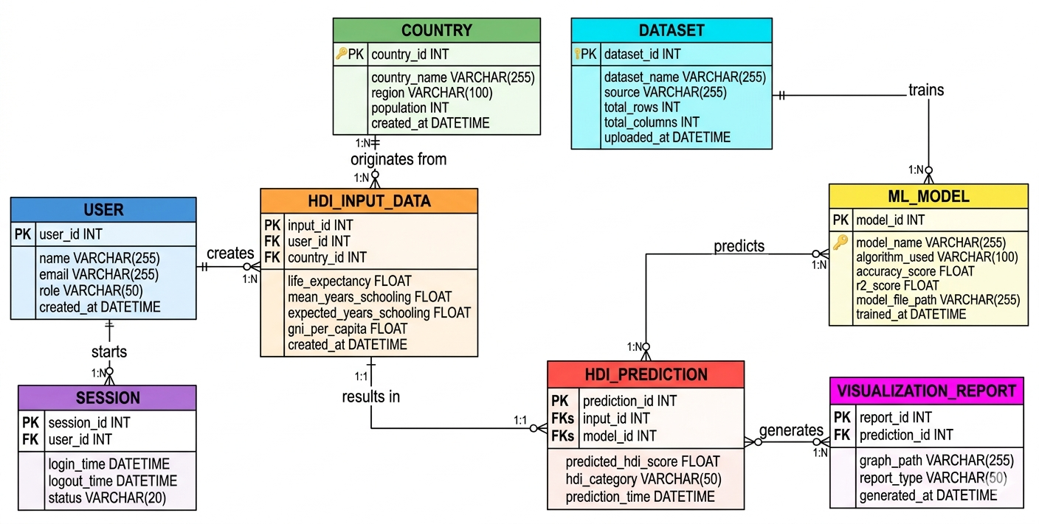
The Entity Relationship (ER) Diagram illustrates the database structure of the A Comprehensive Measure of Well-Being project. It represents the relationships between the core entities involved in the Human Development Index (HDI) prediction system.
The system consists of the following entities:
- User – Stores user details and manages prediction requests.
- Country – Maintains country information used for HDI prediction.
- HDI_Input_Data – Stores input parameters such as life expectancy, mean years of schooling, expected years of schooling, and GNI per capita.
- Dataset – Contains the training dataset used to build the machine learning model.
- ML_Model – Stores the trained machine learning model and its performance details.
- HDI_Prediction – Stores the predicted HDI score and development category generated by the model.
- Visualization_Report – Stores graphs and reports generated from prediction results.
- Session – Maintains user login and activity session details.
Relationships
- One User can create multiple HDI Input Data records (1:N).
- One Country can have multiple HDI Input Data records (1:N).
- Each HDI Input Data record generates one HDI Prediction (1:1).
- One ML Model can generate multiple HDI Predictions (1:N).
- One HDI Prediction can generate multiple Visualization Reports (1:N).
- One Dataset can be used to train multiple ML Models (1:N).
- One User can have multiple Sessions (1:N).

Project Workflow:
The A Comprehensive Measure of Well-Being project follows a systematic workflow to predict the Human Development Index (HDI) using machine learning techniques. The workflow begins with collecting and preprocessing the dataset, followed by training the machine learning model and deploying it through a Flask web application.
Workflow Steps
Step 1: Dataset Collection
- Collect the Human Development Index (HDI) dataset.
- Verify the dataset and understand its features.
Step 2: Data Preprocessing
- Read the dataset using Pandas.
- Check for missing values.
- Select important features such as:
  - Life Expectancy
  - Mean Years of Schooling
  - Expected Years of Schooling
  - GNI per Capita
- Prepare the dataset for training.
Step 3: Data Visualization
- Generate correlation heatmaps.
- Create scatter plots to understand relationships between features.
Step 4: Model Training
- Split the dataset into training and testing sets.
- Train the Linear Regression model.
- Evaluate model performance.
Step 5: Model Saving
- Save the trained model as hdi_model.pkl for future predictions.
Step 6: Flask Web Application
- Develop the frontend using HTML and CSS.
- Build the backend using Flask.
- Connect the trained model with the web application.
Step 7: Prediction
- User enters the required HDI parameters.
- The application processes the input.
- The machine learning model predicts the HDI score.
- The predicted HDI score and development category are displayed.
Step 8: Result Visualization
- Display the prediction result.
- Show graphs and visualizations to help users understand the prediction.

Milestone 1: Model Selection and Architecture
This milestone focuses on setting up the development environment and preparing the project for Human Development Index (HDI) prediction. All the required software, libraries, and dependencies are installed to build and execute the application successfully..
Activity 1.1 – Install Python
Install Python 3.x from the official Python website and verify the installation.
Activity 1.2 – Install Required Libraries
Install all required Python libraries using the Following
command : pip install -r requirements.txt
The required libraries include:
Flask ,Pandas , NumPy , Scikit-lear, ,Matplotlib , Seaborn , Joblib
Activity 1.3 – Project Folder Setup
Organize the project files into the required folder structure.
A-Comprehensive-Measure-of-Well-Being
│
├── data
├── templates
├── README.md
├── requirements.txt
├── train_model.py
├── hdi_model.pkl
└── style.css
Activity 1.4 – Verify Installation
Run the following command to verify that all dependencies are installed correctly.
python templates/app.py
Open the application in your browser.
http://127.0.0.1:5000

Milestone 2: Core Functionalities Development
Core Functionalities Development
Activity 2.1: Dataset Preparation
- Import the HDI dataset.
- Analyze the dataset.
- Handle missing values.
- Select important features.
- Perform data visualization.
Activity 2.2: Machine Learning Model Development
- Split the dataset into training and testing sets.
- Train the Linear Regression model.
- Evaluate model performance.
- Save the trained model (hdi_model.pkl).
Activity 2.3: Flask Backend Development
- Create the Flask application.
- Develop routes for the Home page and Prediction page.
- Load the trained model.
- Accept user input.
- Predict the HDI score.
- Display the prediction result

Milestone 3 Milestone 3: Application Development
Activity 3.1: Developing the Flask Application
- Create the Flask application.
- Load the trained machine learning model.
- Accept user inputs from the web page.
- Predict the Human Development Index.
- Display the prediction result.
Activity 3.2: Frontend Development
- Design the Home page.
- Create the Prediction page.
- Develop the Result page.
- Apply CSS styling.
- Improve user experience

Milestone 4: User Interface Development
Activity 4.1
Develop a responsive interface using HTML and CSS.
Activity 4.2
Create forms to collect:
- Life Expectancy
- Mean Years of Schooling
- Expected Years of Schooling
- GNI per Capita
Display the predicted HDI score and category.

Milestone 5: Deployment
Activity 5.1
Install the required Python packages.
pip install -r requirements.txt
Activity 5.2
Run the application.
python templates/app.py
Open:
http://127.0.0.1:5000
Activity 5.3
Verify that:
- User input is accepted.
- HDI prediction is generated.
- Results are displayed correctly.

Important Notes:
- debug=False is required in run_public.py to prevent Flask from spawning a reloader process, which would interfere with Ngrok’s tunnel management.
- The public URL changes each time you restart run_public.py (on the free Ngrok plan). For a persistent URL, upgrade to a paid Ngrok plan and configure a reserved domain.
- Ngrok free tier sessions expire after a few hours of inactivity. Restart run_public.py to get a new URL when this happens.

Exploring the Website’s Web Pages:
Home / Generator Page:
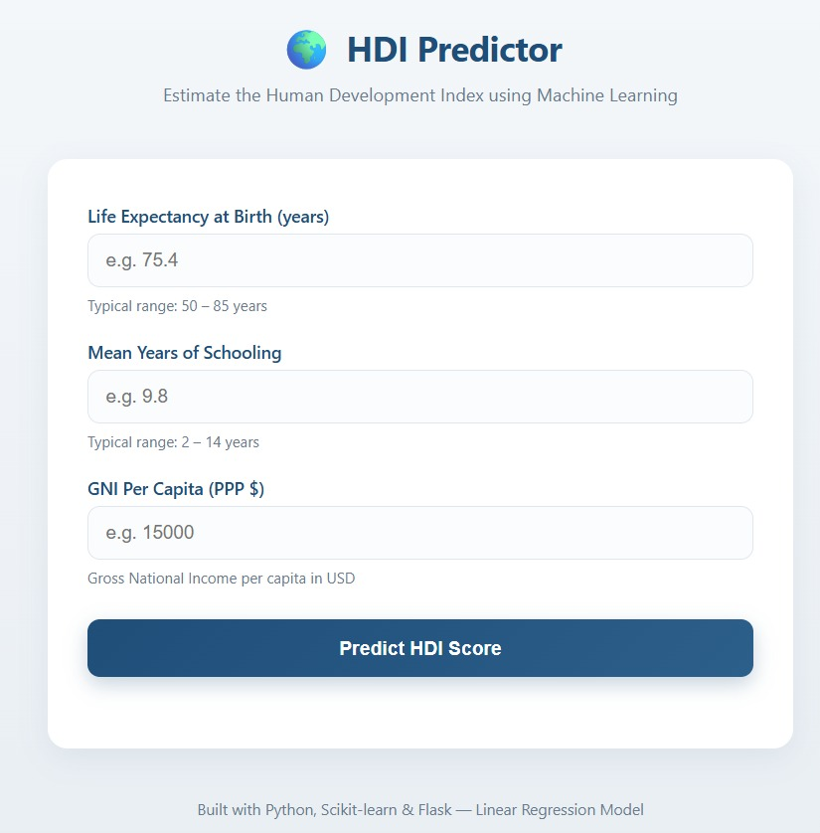
Description: The Home Page serves as the main interface of the A Comprehensive Measure of Well-Being application. Users can enter the required Human Development Index (HDI) parameters, including Life Expectancy, Mean Years of Schooling, Expected Years of Schooling, and GNI per Capita. After entering the values, users can click the Predict HDI Score button to generate the prediction.

Input Section:
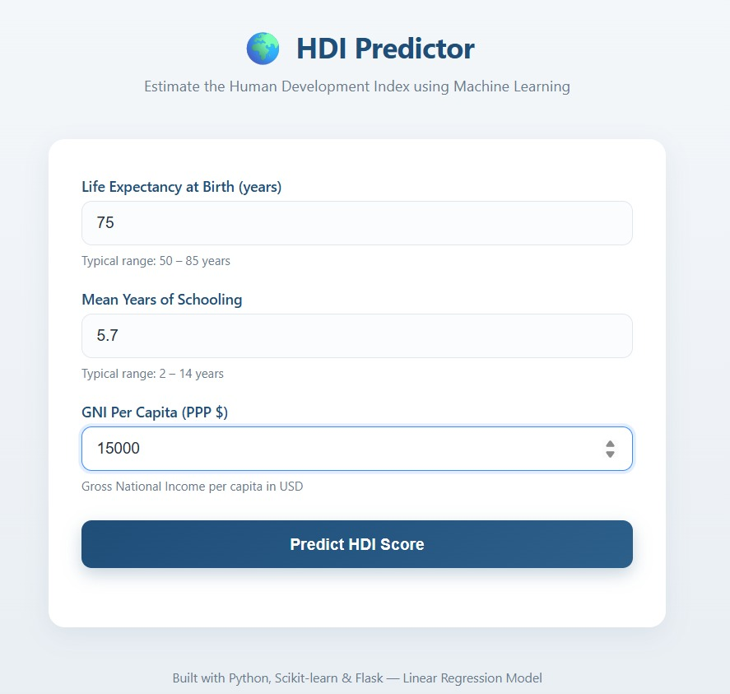
Description: The Input Section allows users to provide the required socio-economic indicators used for HDI prediction. The application validates the entered values and sends them to the trained Linear Regression model for processing. This simple interface ensures that users can easily perform HDI predictions without technical knowledge.
Results Section:
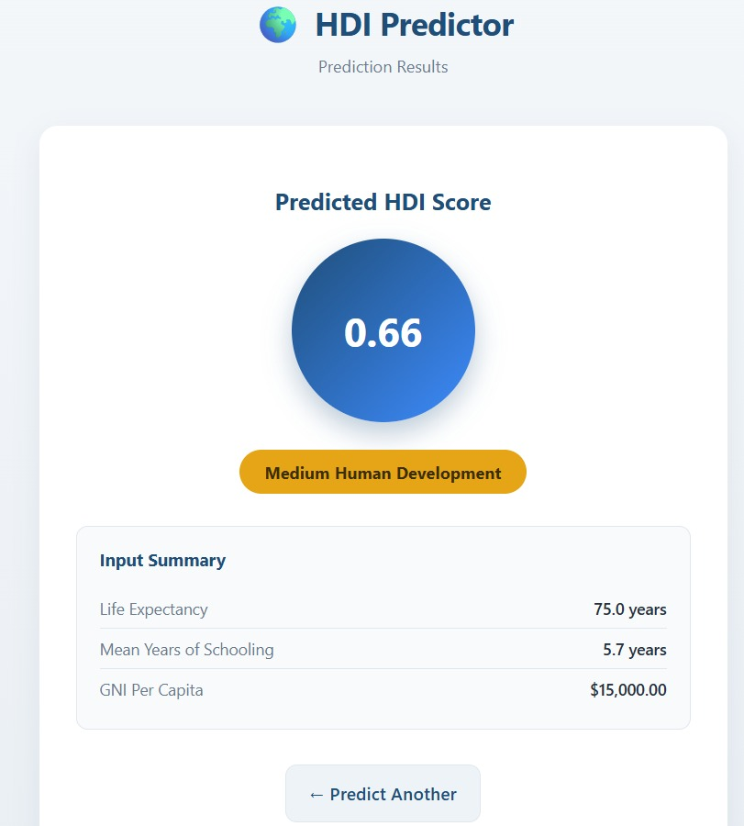
Description: The Results Section displays the predicted Human Development Index (HDI) Score and the corresponding Human Development Category based on the values entered by the user. The prediction is generated using the trained machine learning model and presented in a clear and user-friendly format..
Conclusion:
The A Comprehensive Measure of Well-Being project successfully demonstrates the application of Machine Learning techniques to predict the Human Development Index (HDI) using socio-economic indicators such as Life Expectancy, Mean Years of Schooling, Expected Years of Schooling, and GNI per Capita. The system was developed using Python, Flask, Pandas, NumPy, Scikit-learn, Matplotlib, and HTML/CSS to provide an easy-to-use web application for HDI prediction.
The project enables users to estimate a country's development level quickly and efficiently through a simple web interface. Future improvements may include deploying the application to the cloud, integrating real-time datasets, improving prediction accuracy using advanced machine learning algorithms, and adding interactive data visualization dashboards.

